
acceptable documents for
completing FORM i-9
- For detailed completion instructions, refer to the Using I-9 eXpress Reference Guide (e3081).
- For further assistance, send a Lotus Notes message to Mailbox Employment Compliance,
or call 1-877-576-3681.
Below are the lists of legally acceptable documents. All documents must be unexpired. An employee must present either:
- One item from List A, or
- One item from List B and one item from List C.
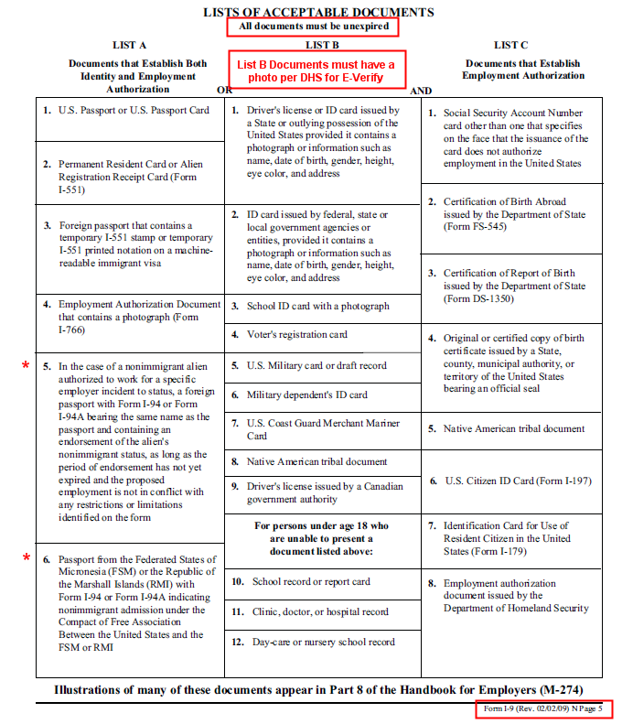

List A Document | Action Item
- In the case of a nonimmigrant alien authorized to work for a specific employer incident to status, a foreign passport with Form I-94 or Form I-94A bearing the same name as the passport and containing an endorsement of the alien’s nonimmigrant status, as long as the period of endorsement has not yet expired and the proposed employment is not in conflict with any restrictions or limitations identified on the form | If an I-94 or I-94A is presented for countries other than Federated States of Micronesia (FSM) or Republic of the Marshall Islands (RMI), immediately contact the Employment Compliance Group for further instruction (1-877-576-3681).
- Passport from the Federated States of Micronesia (FSM) or the Republic of the Marshall Islands (RMI) with Form I-94 or I-94A indicating nonimmigrant admission under the Compact of Free Association Between the United States and the FSM or RMI | If an I-94 or I-94A is presented specifically for FSM or RMI with nonimmigrant admission indicated, accept this document. The employee is entitled to work without an expiration date.

